**Project Design Phase-II**

**Technology Stack (Architecture & Stack)**

|  |  |
| --- | --- |
| Date | 09 November 2022 |
| Team ID | PNT2022TMID53593 |
| Project Name | Project – Real-Time River Water Monitoring and Control System. |
| Maximum Marks | 4 Marks |

**Technical Architecture:**

The Deliverable shall include the architectural diagram as below and the information as per the table1 & table 2

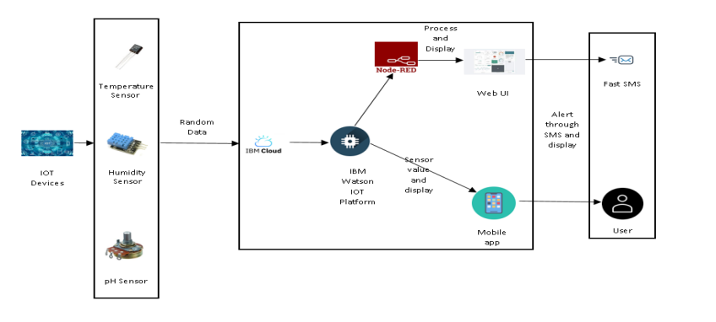

**Table-1 : Components & Technologies:**

|  |  |  |  |
| --- | --- | --- | --- |
| **S.No** | **Component** | **Description** | **Technology** |
|  | User Interface | Web UI, Mobile App | Node – Red, Kubernetes, MIT mobile app inventor. |
|  | Application Logic-1 | Generate Random data | Python |
|  | Application Logic-2 | Generate random sensor data | IBM Watson IoT service |
|  | Cloud Database | Database Service on Cloud | IBM DB2, IBM Cloudant. |
|  | External API-1 | Send SMS to customer | Fast SMS API. |
|  | Infrastructure (Server / Cloud) | Application Deployment on Cloud | Cloud Foundry, Kubernetes. |

**Table-2: Application Characteristics:**

| **S.No** | **Characteristics** | **Description** | **Technology** |
| --- | --- | --- | --- |
|  | Open-Source Frameworks | The open-source tools we utilized to create our project | Node – Red, IBM Cloudant, IBM Watson IOT Platform. |
|  | Security Implementations | Use of a login page with a user's unique username and password on a web interface optimized for mobile devices and computers with adjustable screen sizes | Password protection in MIT App. |
|  | Scalable Architecture | optimized for mobile devices and computers with adjustable screen sizes | Node Red(Web UI) |
|  | Availability | accessible to users through both a web UI and a mobile app | Node Red(Web UI), MIT App(Mobile app). |
|  | Performance | Give precise results and a prompt warning in the event of water contamination | Node Red(Web UI), MIT App(Mobile app). |